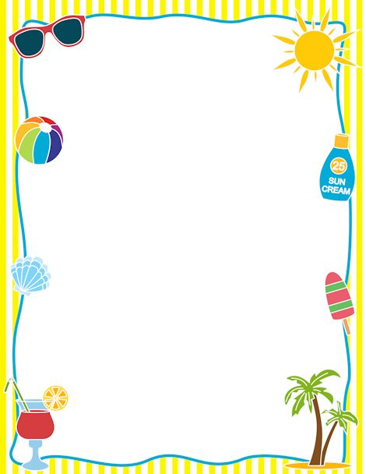

**GCP PTA & GCP BLT are hosting an “Author’s Night”**

**Meet authors, buy books, & have your books signed**

**Where:** Garden City Park School Gym

**When:** Thurs., June 14th 6:00 – 8:00 p.m.

**All children MUST be accompanied by an adult.**

**Kick Off**